# Graphics for Games Report

In this report, I will be going through my graphics assignment and breaking down the various features implemented with the help of screenshots. The implementation of these features will also be explained briefly to assist in the overall understanding of the submitted project.

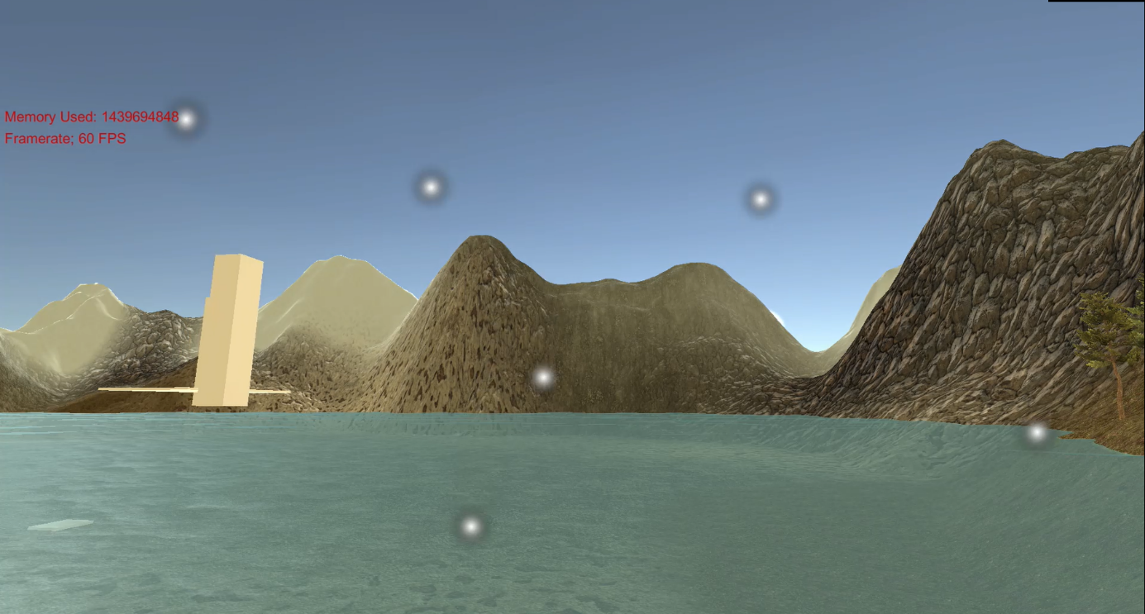

In the above screenshot, the multiple textures used for the terrain as well as the shader for the realistic water can be seen. Also visible is the Memory used as well as framerate displayed near the top right of the camera. Snow can be seen falling, suiting the theme of the snowy mountains in the background. The URP (Universal Render Pipeline) was used to implement the realistic water shader, allowing for the display of waves as well as reflected light among other details.

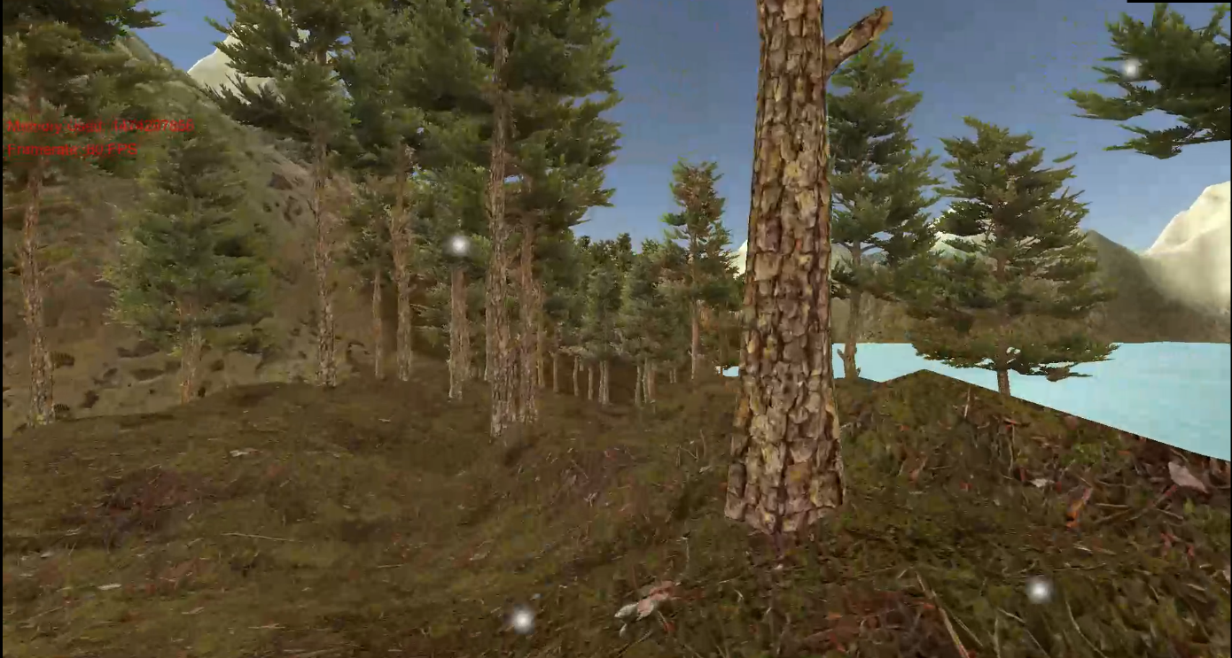

The various textures as well as objects utilized in the project can be seen in this screenshot. The assets were taken from the Unity default assets. The terrain consists of different textures overlapping with varying opacity to project a somewhat realistic feeling. The trees have colliders and can be collided with the player.

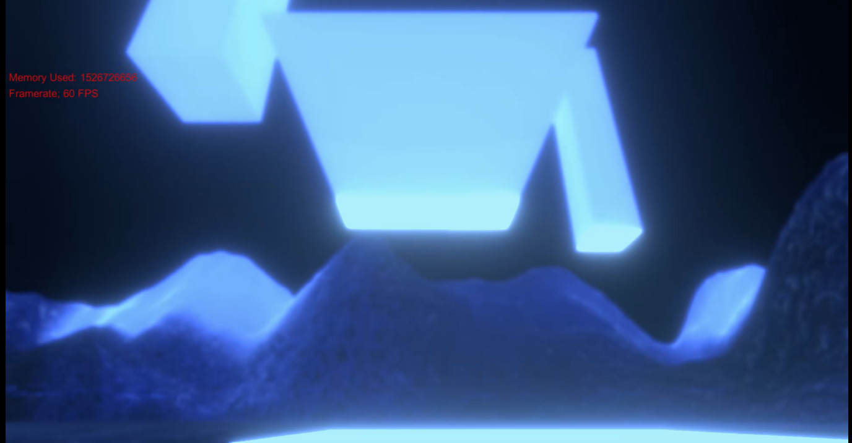

Various post processing feature can be observed in the above screenshot. URP post processing was used to implement these features which include the blur, bloom, differing depth perception as well as the bluish tint. These features really provide a realistic feel to the water that goes beyond the surface level appearance. It can be noticed that the snow is no longer visible underwater. The sun can no longer be seen, having set, portraying the implementation of a day/ night cycle feature. Pillars can be seen rotating the elevated platform as well as a platform moving up and down to provide access to it.

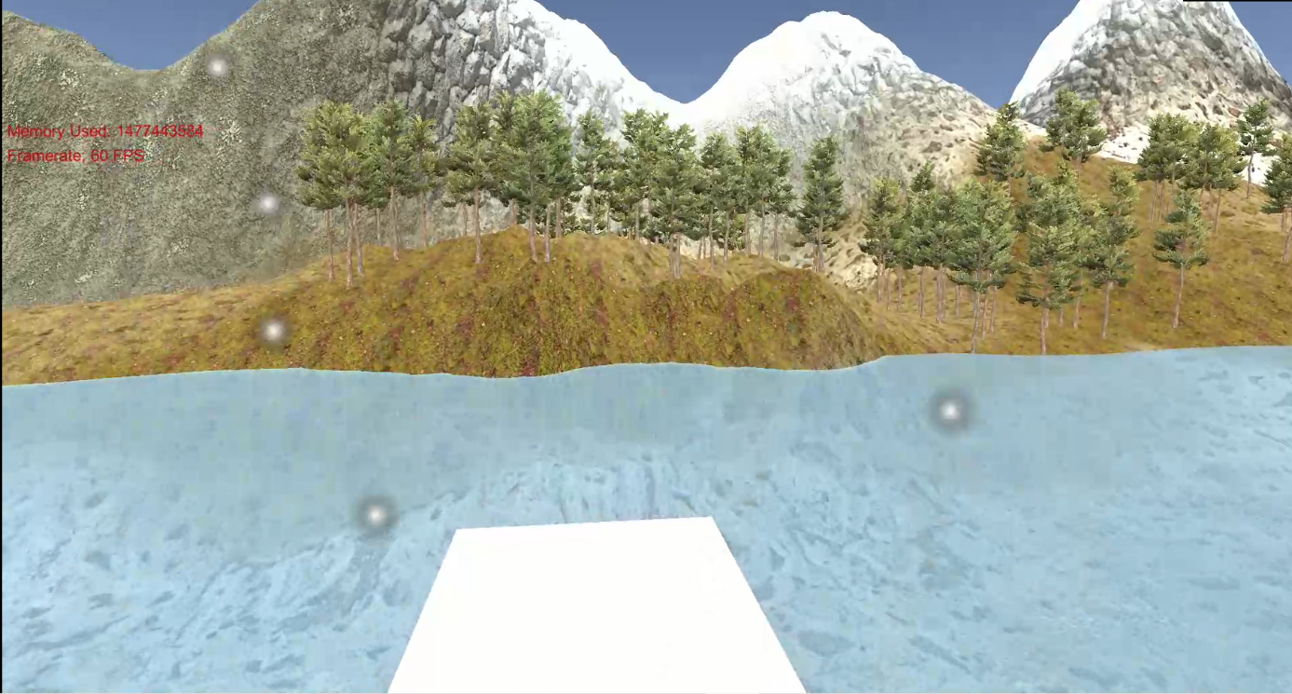

The last screenshot provides the view from the floating platform above the body of water. It can be noted that the snow on display is a particle effect present above the camera and attached to the player as a child component. This is to avoid having to constantly render snow throughout the scene as well as display good scene management. The floating pillars are similarly attached to the platform.

Overall, I feel that the project has been implemented with the necessary number of features to a acceptable degree of quality. If I had to pick something I would improve on, it would be the texture of the snow. The current snow uses the unity particle effect default texture, but I feel that this could have been replaced with a more realistic texture. This is important as the snow is almost always in the view of the camera.

# YouTube link

The following is the link to the unlisted YouTube video of the project running.

<https://youtu.be/dD2DQMs8tbs>